**VISVESVARAYA TECHNOLOGICAL UNIVERSITY**

**“JnanaSangama”, Belgaum -590014, Karnataka.**



## LAB REPORT

**on**

Machine Learning (20CS6PCMAL)

***Submitted by***

## Kizhakel Sharat Prasad (1BM19CS074)

***in partial fulfillment for the award of the degree of***

**BACHELOR OF ENGINEERING**

***in***

## COMPUTER SCIENCE AND ENGINEERING



**B.M.S. COLLEGE OF ENGINEERING**

(Autonomous Institution under VTU)

## BENGALURU-560019

**May-2022 to July-2022**

**B. M. S. College of Engineering,**

Bull Temple Road, Bangalore 560019

(Affiliated To Visvesvaraya Technological University, Belgaum)

**Department of Computer Science and Engineering**



**C ERTIFICATE**

This is to certify that the Lab work entitled “Machine Learning” carried out by **Kizhakel Sharat Prasad (1BM19CS074),** who is bonafide student of **B. M. S. College of Engineering.** It is in partial fulfillment for the award of **Bachelor of Engineering in Computer Science and Engineering** of the Visvesvaraya Technological University, Belgaum during the year 2022. The Lab report has been approved as it satisfies the academic requirements in respect of a **Machine Learning (20CS6PCMAL)** work prescribed for the said degree.

Saritha A.N. **Dr. Jyothi S Nayak**

Assistant Professor Professor and Head

Department of CSE Department of CSE

BMSCE, Bengaluru BMSCE, Bengaluru

`

**Index Sheet**

|  |  |  |
| --- | --- | --- |
| **Sl.**  **No.** | **Experiment Title** | **Page No.** |
| **1** | **Implement and demonstrate the FIND-S algorithm for finding the most specific hypothesis based on a given set of training data samples.** |  |
| **2** | **For a given set of training data examples stored in a .CSV file, implement and demonstrate the Candidate-Elimination algorithm to output a description of the set of all hypotheses consistent with the training**  **examples.** |  |
| **3** | **Write a program to demonstrate the working of the decision tree based ID3 algorithm. Use an appropriate data set for building the decision tree and apply this knowledge to classify a new sample.** |  |
| **4** | **Write a program to implement the naïve Bayesian classifier for a sample training data set stored as a .CSV file. Compute the accuracy of the classifier, considering few test**  **data sets** |  |
| **5** | **Implement the Linear Regression algorithm in order to fit data points. Select appropriate data set for your experiment and draw graphs** |  |
| **6** | **Bayesian network** |  |

|  |  |  |
| --- | --- | --- |
| **7** | **k-Means algorithm** |  |
| **8** | **EM algorithm** |  |
| **9** | **k-Nearest Neighbour algorithm** |  |
| **10** | **Non-Parametric Locally Weighted Regression algorithm** |  |

**Course Outcome**

|  |  |
| --- | --- |
| CO1 | Ability to apply the different learning algorithms. |
| CO2 | Ability to analyze the learning techniques for given dataset. |
| CO3 | Ability to design a model using machine learning to solve a problem. |
| CO4 | Ability to conduct practical experiments to solve problems using appropriate machine learning techniques |

1. **Implement and demonstrate the FIND-S algorithm for finding the most specific hypothesis based on a given set of training data samples.**

import numpy as np import pandas as pd

data = pd.read_csv("mydata.csv") print(data,"\n")

d = np.array(data)[:,:-1] print("\n The attributes are: ",d) target = np.array(data)[:,-1] print("\n The target is: ",target) def findS(c,t):

for i, val in enumerate(t):

if val == "Yes":

specific_hypothesis = c[i].copy() break

for i, val in enumerate(c):

if t[i] == "Yes":

for x in range(len(specific_hypothesis)):

if val[x] != specific_hypothesis[x]: specific_hypothesis[x] = '?'

else:

pass

return specific_hypothesis

print("\n The final hypothesis is:",findS(d,target))

**Dataset:**

**Time Weather Temperature Company Humidity Wind Goes**

|  |  |  |  |  |  |  |
| --- | --- | --- | --- | --- | --- | --- |
| **0 Morning Sunny** | **Warm** |  | **Yes** | **Mild** | **Strong Yes** | |
| **1 Evening Rainy** | **Cold** | **No** | **No** | **Mild** | **Normal No** | |
| **2 Morning Sunny** | **Moderate** | | **Yes** | **Normal** | **Normal** | **Yes** |
| **3 Evening Sunny** | **Cold** | | **Yes** | **High** | **Strong** | **Yes** |

**Output:**

The final hypothesis is: ['?' 'Sunny' '?' 'Yes' '?' '?']

# For a given set of training data examples stored in a .CSV file, implement and demonstrate the Candidate-Elimination algorithm to output a description of the set of all hypotheses consistent with the training examples.

import numpy as np import pandas as pd

data=pd.DataFrame(data=pd.read_csv('data.csv')) print(data)

concepts=np.array(data.iloc[:,0:-1]) print("The attributes are : ",concepts) target=np.array(data.iloc[:,-1])

print ("\n The target is =",target) def learn(concepts,target):

specific_h=concepts[0].copy()

print("\n Initialization of specfic_h and generalization") print(specific_h)

general_h = [["?" for i in range(len(specific_h))] for i in range(len(specific_h))] print(general_h)

for i,h in enumerate(concepts):

print("For loop starts") if target[i] =="yes":

print("If instance is positive") for x in range(len(specific_h)):

if h[x]!=specific_h[x]:

specific_h[x]='?' general_h[x][x]='?'

if target[i]=="no":

print("If instance is negative ") for x in range(len(specific_h)):

if h[x] !=specific_h[x]: general_h[x][x]=specific_h[x]

else:

general_h[x][x]='?'

print("steps of candidate elimination algorithm",i+1) print(specific_h)

print(general_h) print("\n")

print("\n")

indices=[i for i,val in enumerate(general_h) if val==['?','?','?']] for i in indices:

general_h.remove(['?','?','?']) return specific_h,general_h

s_final, g_final = learn(concepts, target) print("Final specific_h:",s_final,sep="\n") print("Final General_h:",g_final,sep="\n")

**Dataset:**

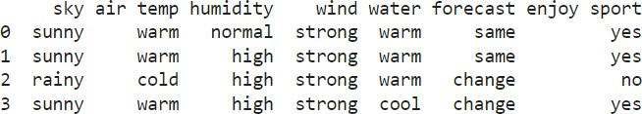

**Output:**

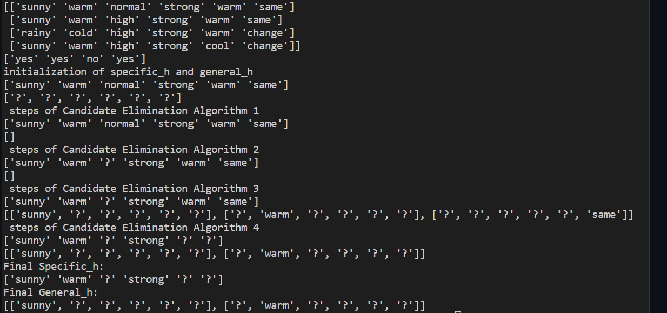

1. **Write a program to demonstrate the working of the decision tree based ID3 algorithm. Use an appropriate data set for building the decision tree and apply this knowledge to classify a new sample.**

import math import csv

def load_csv(filename): lines=csv.reader(open(filename,"r")); dataset = list(lines)

headers = dataset.pop(0) return dataset,headers

class Node:

def init (self,attribute): self.attribute=attribute self.children=[] self.answer=""

def subtables(data,col,delete):

dic={}

coldata=[row[col] for row in data] attr=list(set(coldata))

counts=[0]*len(attr) r=len(data) c=len(data[0])

for x in range(len(attr)):

for y in range(r):

if data[y][col]==attr[x]:

counts[x]+=1

for x in range(len(attr)):

dic[attr[x]]=[[0 for i in range(c)] for j in range(counts[x])] pos=0

for y in range(r):

if data[y][col]==attr[x]:

if delete:

del data[y][col] dic[attr[x]][pos]=data[y] pos+=1

return attr,dic def entropy(S):

attr=list(set(S)) if len(attr)==1:

return 0

counts=[0,0]

for i in range(2):

counts[i]=sum([1 for x in S if attr[i]==x])/(len(S)*1.0)

sums=0

for cnt in counts:

sums+=-1*cnt*math.log(cnt,2) return sums

def compute_gain(data,col):

attr,dic = subtables(data,col,delete=False)

total_size=len(data) entropies=[0]*len(attr) ratio=[0]*len(attr)

total_entropy=entropy([row[-1] for row in data]) for x in range(len(attr)):

ratio[x]=len(dic[attr[x]])/(total_size*1.0) entropies[x]=entropy([row[-1] for row in dic[attr[x]]]) total_entropy-=ratio[x]*entropies[x]

return total_entropy

def build_tree(data,features): lastcol=[row[-1] for row in data] if(len(set(lastcol)))==1:

node=Node("") node.answer=lastcol[0] return node

n=len(data[0])-1 gains=[0]*n

for col in range(n): gains[col]=compute_gain(data,col)

split=gains.index(max(gains)) node=Node(features[split])

fea = features[:split]+features[split+1:] attr,dic=subtables(data,split,delete=True)

for x in range(len(attr)): child=build_tree(dic[attr[x]],fea) node.children.append((attr[x],child))

return node

def print_tree(node,level): if node.answer!="":

print(" "*level,node.answer) return

print(" "*level,node.attribute) for value,n in node.children:

print(" "*(level+1),value) print_tree(n,level+2)

def classify(node,x_test,features): if node.answer!="":

print(node.answer) return

pos=features.index(node.attribute)

for value, n in node.children:

if x_test[pos]==value: classify(n,x_test,features)

'''Main program''' dataset,features=load_csv("id3.csv") node1=build_tree(dataset,features)

print("The decision tree for the dataset using ID3 algorithm is") print_tree(node1,0) testdata,features=load_csv("id3_test_1.csv")

for xtest in testdata:

print("The test instance:",xtest)

print("The label for test instance:",end=" ") classify(node1,xtest,features)

**Dataset:**



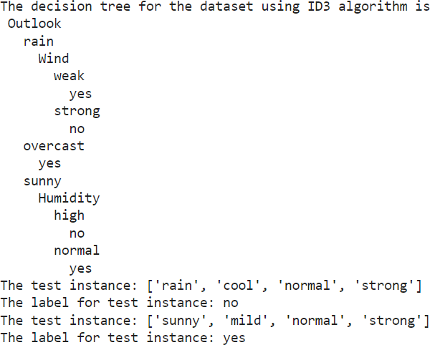**Output:**

1. **Write a program to implement the naïve Bayesian classifier for a sample training data set stored as a .CSV file. Compute the accuracy of the classifier, considering few test data sets**

import pandas as pd

from sklearn.model_selection import train_test_split from sklearn.naive_bayes import GaussianNB

from sklearn import metrics

df = pd.read_csv("diabetes.csv")

col_names = ['num_preg', 'glucose_conc', 'diastolic_bp', 'thickness', 'insulin', 'bmi', 'diab_pred', 'age'] predicted_class = ['diabetes']

X = df[col_names].values

y = df[predicted_class].values print(df.head)

xtrain,xtest,ytrain,ytest=train_test_split(X,y,test_size=0.4)

print ('\n the total number of Training Data :',ytrain.shape) print ('\n the total number of Test Data :',ytest.shape)

clf = GaussianNB().fit(xtrain,ytrain.ravel()) predicted = clf.predict(xtest)

predictTestData= clf.predict([[6,148,72,35,0,33.6,0.627,50]]) print('\n Confusion matrix') print(metrics.confusion_matrix(ytest,predicted))

print('\n Accuracy of the classifier is',metrics.accuracy_score(ytest,predicted)) print('\n The value of Precision', metrics.precision_score(ytest,predicted)) print('\n The value of Recall', metrics.recall_score(ytest,predicted)) print("Predicted Value for individual Test Data:", predictTestDat

**Dataset:**

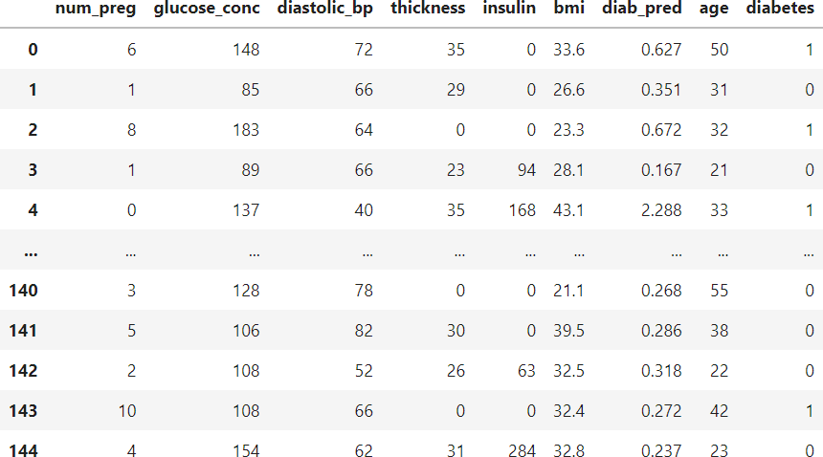

**Output:**

Confusion matrix

[[32 i0]

[ 9 7]j

### Accuracy of the classifier is 0.6724137931034483

The va1ue of Prec1s ton 0. 4117647058823529

The value of Recall 0.4375

Predicted Value for individual Test Data: [lj

1. **Implement the Linear Regression algorithm in order to fit data points. Select appropriate data set for your experiment and draw graphs**

import numpy as np

import matplotlib.pyplot as plt import pandas as pd

dataset = pd.read_csv('salary_data.csv')

X = dataset.iloc[:, :-1].values y = dataset.iloc[:, 1].values

from sklearn.model_selection import train_test_split

X_train, X_test, y_train, y_test = train_test_split(X, y, test_size=

***# Fitting Simple Linear Regression to the Training set* from sklearn.linear_model import LinearRegression regressor = LinearRegression()**

regressor.fit(X_train, y_train)

***# Predicting the Test set results***

y_pred = regressor.predict(X_test)

***# Visualizing the Training set results***

viz_train = plt

viz_train.scatter(X_train, y_train, color='red') viz_train.plot(X_train, regressor.predict(X_train), color='blue') viz_train.title('Salary VS Experience (Training set)') viz_train.xlabel('Year of Experience')

viz_train.ylabel('Salary') viz_train.show()

***# Visualizing the Test set results***

viz_test = plt

viz_test.scatter(X_test, y_test, color='red') viz_test.plot(X_train, regressor.predict(X_train), color='blue') viz_test.title('Salary VS Experience (Test set)') viz_test.xlabel('Year of Experience')

viz_test.ylabel('Salary') viz_test.show() regressor.score(X_train,y_train) print(regressor.score(X_test,y_test))

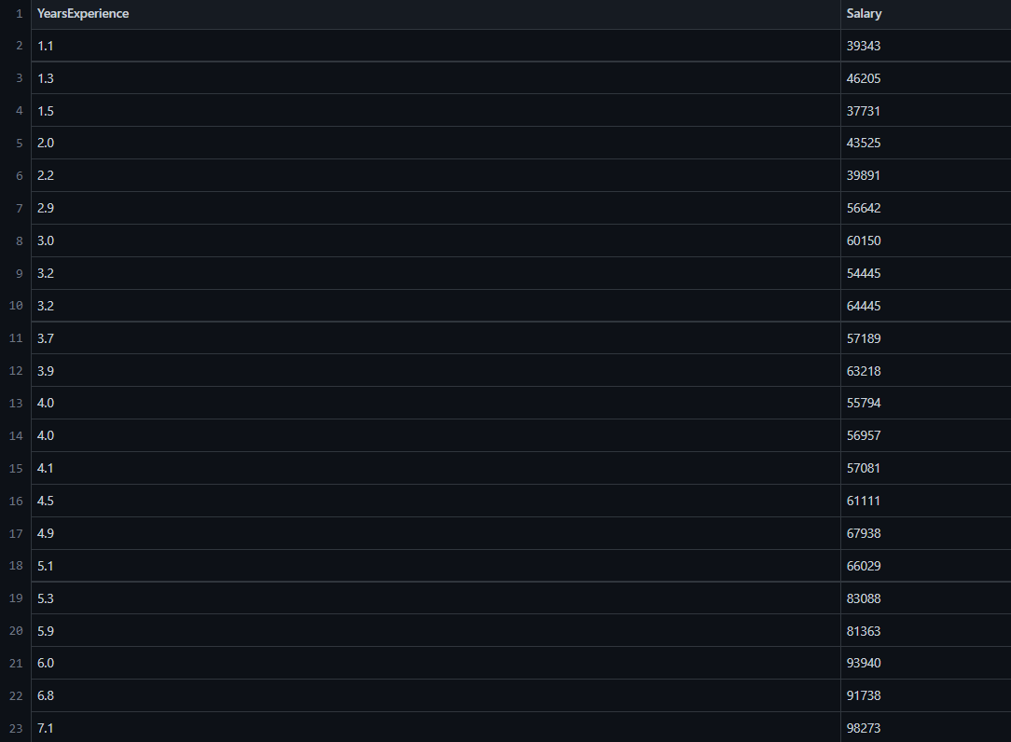**Dataset:**

**Output:**

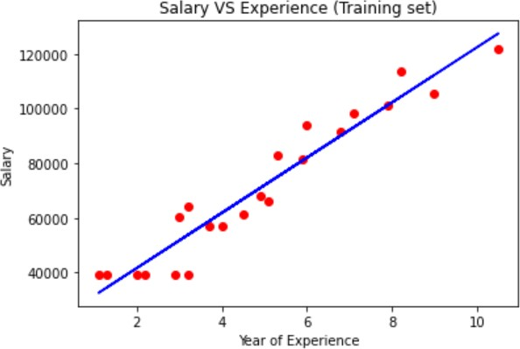

#### 120000

100000

80000

WOOO

QOOOO

Salary VS Experience (Test set)

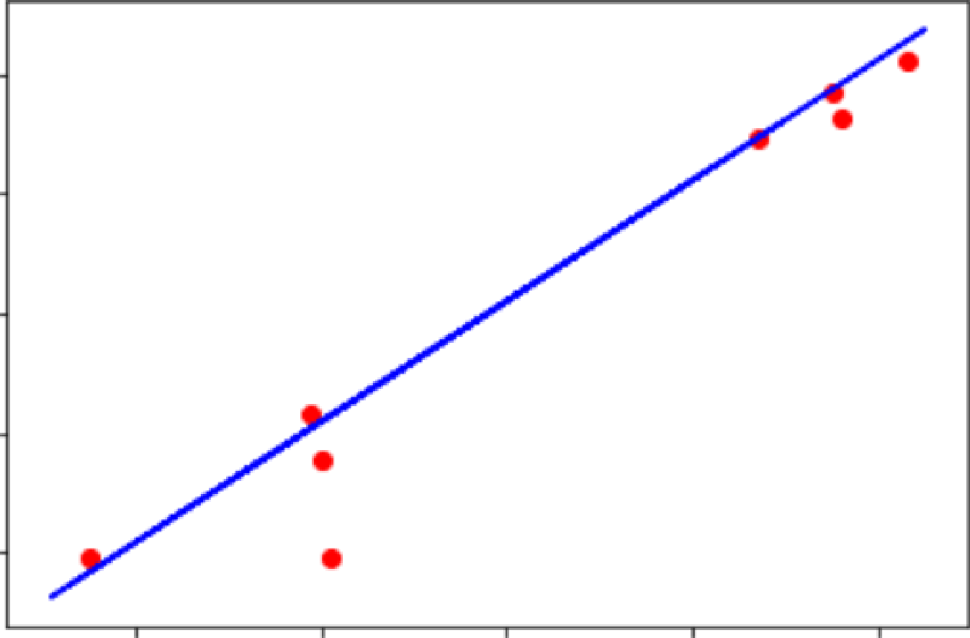2

0.9251138619118122

**6. Write a program to construct a Bayesian network considering training data. Use this model to make predictions**

**a) Using built-in:**

!pip install pgmpy

import numpy as np

import pandas as pd

import csv

from pgmpy.estimators import MaximumLikelihoodEstimator

from pgmpy.models import BayesianModel

from pgmpy.inference import VariableElimination

heartDisease = pd.read_csv('heart_disease.csv')

heartDisease = heartDisease.replace('?',np.nan)

print('Sample instances from the dataset are given below')

print(heartDisease.head())

print('\n Attributes and datatypes')

print(heartDisease.dtypes)

model= BayesianModel([('age','Heartdisease'),('sex','Heartdisease'),('exang','Heartdisease'),('cp','Heartdisease'),('Heartdisease','restecg'),('Heartdisease','chol')])

print('\nLearning CPD using Maximum likelihood estimators')

model.fit(heartDisease,estimator=MaximumLikelihoodEstimator)

print('\n Inferencing with Bayesian Network:')

HeartDiseasetest_infer = VariableElimination(model)

print('\n 1. Probability of HeartDisease given evidence= restecg')

q1=HeartDiseasetest_infer.query(variables=['Heartdisease'],evidence={'restecg':1})

print(q1)

print('\n 2. Probability of HeartDisease given evidence= cp ')

q2=HeartDiseasetest_infer.query(variables=['Heartdisease'],evidence={'cp':2})

print(q2)

**Output:**

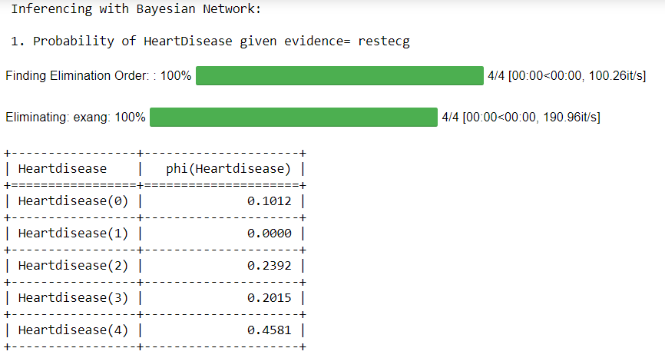

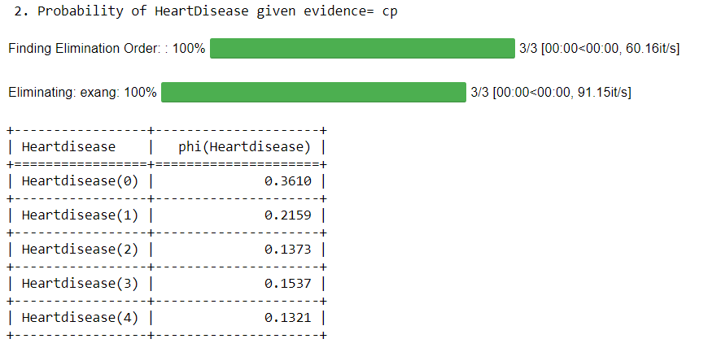

**b) Without using built-in:**

import bayespy as bp

import numpy as np

import csv

from colorama import init

from colorama import Fore, Back, Style

init()

# Define Parameter Enum values

# Age

ageEnum = {'SuperSeniorCitizen': 0, 'SeniorCitizen': 1,

'MiddleAged': 2, 'Youth': 3, 'Teen': 4}

# Gender

genderEnum = {'Male': 0, 'Female': 1}

# FamilyHistory

familyHistoryEnum = {'Yes': 0, 'No': 1}

# Diet(Calorie Intake)

dietEnum = {'High': 0, 'Medium': 1, 'Low': 2}

# LifeStyle

lifeStyleEnum = {'Athlete': 0, 'Active': 1, 'Moderate': 2, 'Sedetary': 3}

# Cholesterol

cholesterolEnum = {'High': 0, 'BorderLine': 1, 'Normal': 2}

# HeartDisease

heartDiseaseEnum = {'Yes': 0, 'No': 1}

import pandas as pd

data = pd.read_csv("heart_disease_data.csv")

data =np.array(data, dtype='int8')

N = len(data)

# Input data column assignment

p_age = bp.nodes.Dirichlet(1.0*np.ones(5))

age = bp.nodes.Categorical(p_age, plates=(N,))

age.observe(data[:, 0])

p_gender = bp.nodes.Dirichlet(1.0*np.ones(2))

gender = bp.nodes.Categorical(p_gender, plates=(N,))

gender.observe(data[:, 1])

p_familyhistory = bp.nodes.Dirichlet(1.0*np.ones(2))

familyhistory = bp.nodes.Categorical(p_familyhistory, plates=(N,))

familyhistory.observe(data[:, 2])

p_diet = bp.nodes.Dirichlet(1.0*np.ones(3))

diet = bp.nodes.Categorical(p_diet, plates=(N,))

diet.observe(data[:, 3])

p_lifestyle = bp.nodes.Dirichlet(1.0*np.ones(4))

lifestyle = bp.nodes.Categorical(p_lifestyle, plates=(N,))

lifestyle.observe(data[:, 4])

p_cholesterol = bp.nodes.Dirichlet(1.0*np.ones(3))

cholesterol = bp.nodes.Categorical(p_cholesterol, plates=(N,))

cholesterol.observe(data[:, 5])

p_heartdisease = bp.nodes.Dirichlet(np.ones(2), plates=(5, 2, 2, 3, 4, 3))

heartdisease = bp.nodes.MultiMixture(

[age, gender, familyhistory, diet, lifestyle, cholesterol], bp.nodes.Categorical, p_heartdisease)

heartdisease.observe(data[:, 6])

p_heartdisease.update()

m = 0

while m == 0:

print("\n")

res = bp.nodes.MultiMixture([int(input('Enter Age: ' + str(ageEnum))), int(input('Enter Gender: ' + str(genderEnum))), int(input('Enter FamilyHistory: ' + str(familyHistoryEnum))), int(input('Enter dietEnum: ' + str(

dietEnum))), int(input('Enter LifeStyle: ' + str(lifeStyleEnum))), int(input('Enter Cholesterol: ' + str(cholesterolEnum)))], bp.nodes.Categorical, p_heartdisease).get_moments()[0][heartDiseaseEnum['Yes']]

print("Probability(HeartDisease) = " + str(res))

# print(Style.RESET_ALL)

m = int(input("Enter for Continue:0, Exit :1 "))

**Output:**

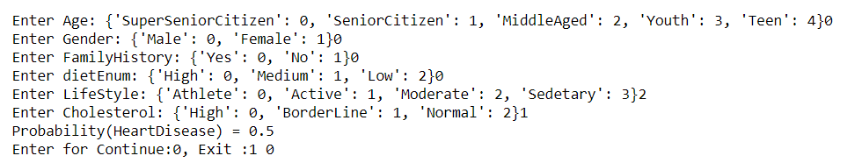

**7. Apply k-Means algorithm to cluster a set of data stored in a .CSV file**

**a) Using built-in:**

import pandas as pd

from sklearn.cluster import KMeans

from sklearn.preprocessing import MinMaxScaler

from matplotlib import pyplot as plt

%matplotlib inline

df = pd.read_csv('income.csv')

df.head(10)

scaler = MinMaxScaler()

scaler.fit(df[['Age']])

df[['Age']] = scaler.transform(df[['Age']])

scaler.fit(df[['Income($)']])

df[['Income($)']] = scaler.transform(df[['Income($)']])

df.head(10)

plt.scatter(df['Age'], df['Income($)'])

k_range = range(1, 11)

sse = []

for k in k_range:

kmc = KMeans(n_clusters=k)

kmc.fit(df[['Age', 'Income($)']])

sse.append(kmc.inertia_)

plt.xlabel = 'Number of Clusters'

plt.ylabel = 'Sum of Squared Errors'

plt.plot(k_range, sse)

km = KMeans(n_clusters=3)

km

df0 = df[df.cluster == 0]

df0

df1 = df[df.cluster == 1]

df1

df2 = df[df.cluster == 2]

df2

p1 = plt.scatter(df0['Age'], df0['Income($)'], marker='+', color='red')

p2 = plt.scatter(df1['Age'], df1['Income($)'], marker='*', color='blue')

p3 = plt.scatter(df2['Age'], df2['Income($)'], marker='^', color='green')

c = plt.scatter(km.cluster_centers_[:,0], km.cluster_centers_[:,1], color='black')

plt.xlabel('Age')

plt.ylabel('Income($)')

plt.legend((p1, p2, p3, c),

('Cluster 1', 'Cluster 2', 'Cluster 3', 'Centroid'))

**Output:**

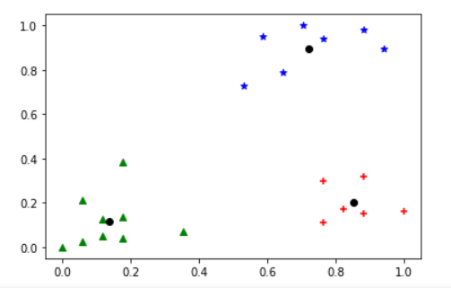

**b) Without using built-in:**

import math;

import sys;

import pandas as pd

import numpy as np

from random import choice

from matplotlib import pyplot

from random import shuffle, uniform;

def ReadData(fileName):

f = open(fileName,'r')

lines = f.read().splitlines()

f.close()

items = []

for i in range(1,len(lines)):

line = lines[i].split(',')

itemFeatures = []

for j in range(len(line)-1):

v = float(line[j])

itemFeatures.append(v)

items.append(itemFeatures)

shuffle(items)

return items

def FindColMinMax(items):

n = len(items[0])

minima = [float('inf') for i in range(n)]

maxima = [float('-inf') -1 for i in range(n)]

for item in items:

for f in range(len(item)):

if(item[f] < minima[f]):

minima[f] = item[f]

if(item[f] > maxima[f]):

maxima[f] = item[f]

return minima,maxima

def EuclideanDistance(x,y):

S = 0

for i in range(len(x)):

S += math.pow(x[i]-y[i],2)

return math.sqrt(S)

def InitializeMeans(items,k,cMin,cMax):

f = len(items[0])

means = [[0 for i in range(f)] for j in range(k)]

for mean in means:

for i in range(len(mean)):

mean[i] = uniform(cMin[i]+1,cMax[i]-1)

return means

def UpdateMean(n,mean,item):

for i in range(len(mean)):

m = mean[i]

m = (m*(n-1)+item[i])/float(n)

mean[i] = round(m,3)

return mean

def FindClusters(means,items):

clusters = [[] for i in range(len(means))]

for item in items:

index = Classify(means,item)

clusters[index].append(item)

return clusters

def Classify(means,item):

minimum = float('inf');

index = -1

for i in range(len(means)):

dis = EuclideanDistance(item,means[i])

if(dis < minimum):

minimum = dis

index = i

return index

def CalculateMeans(k,items,maxIterations=100000):

cMin, cMax = FindColMinMax(items)

means = InitializeMeans(items,k,cMin,cMax)

clusterSizes = [0 for i in range(len(means))]

belongsTo = [0 for i in range(len(items))]

for e in range(maxIterations):

noChange = True;

for i in range(len(items)):

item = items[i];

index = Classify(means,item)

clusterSizes[index] += 1

cSize = clusterSizes[index]

means[index] = UpdateMean(cSize,means[index],item)

if(index != belongsTo[i]):

noChange = False

belongsTo[i] = index

if (noChange):

break

return means

def CutToTwoFeatures(items,indexA,indexB):

n = len(items)

X = []

for i in range(n):

item = items[i]

newItem = [item[indexA],item[indexB]]

X.append(newItem)

return X

def PlotClusters(clusters):

n = len(clusters)

X = [[] for i in range(n)]

for i in range(n):

cluster = clusters[i]

for item in cluster:

X[i].append(item)

colors = ['r','b','g','c','m','y']

for x in X:

c = choice(colors)

colors.remove(c)

Xa = []

Xb = []

for item in x:

Xa.append(item[0])

Xb.append(item[1])

pyplot.plot(Xa,Xb,'o',color=c)

pyplot.show()

def main():

items = ReadData('data.txt')

k = 3

items = CutToTwoFeatures(items,2,3)

print(items)

means = CalculateMeans(k,items)

print("\nMeans = ", means)

clusters = FindClusters(means,items)

PlotClusters(clusters)

newItem = [1.5,0.2]

print(Classify(means,newItem))

if __name__ == "__main__":

main()

**Output:**

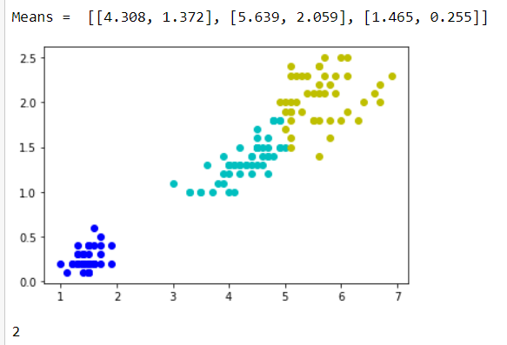

**8. Apply EM algorithm to cluster a set of data stored in a .CSV file. Compare the results of k-Means algorithm and EM algorithm.**

import matplotlib.pyplot as plt

from sklearn import datasets

from sklearn.cluster import KMeans

import sklearn.metrics as sm

import pandas as pd

import numpy as np

iris = datasets.load_iris()

X = pd.DataFrame(iris.data)

X.columns = ['Sepal_Length','Sepal_Width','Petal_Length','Petal_Width']

y = pd.DataFrame(iris.target)

y.columns = ['Targets']

model = KMeans(n_clusters=3)

model.fit(X)

plt.figure(figsize=(14,7))

colormap = np.array(['red', 'lime', 'black'])

# Plot the Original Classifications

plt.subplot(1, 2, 1)

plt.scatter(X.Petal_Length, X.Petal_Width, c=colormap[y.Targets], s=40)

plt.title('Real Classification')

plt.xlabel('Petal Length')

plt.ylabel('Petal Width')

# Plot the Models Classifications

plt.subplot(1, 2, 2)

plt.scatter(X.Petal_Length, X.Petal_Width, c=colormap[model.labels_], s=40)

plt.title('K Mean Classification')

plt.xlabel('Petal Length')

plt.ylabel('Petal Width')

print('The accuracy score of K-Mean: ',sm.accuracy_score(y, model.labels_))

print('The Confusion matrixof K-Mean: ',sm.confusion_matrix(y, model.labels_))

from sklearn import preprocessing

scaler = preprocessing.StandardScaler()

scaler.fit(X)

xsa = scaler.transform(X)

xs = pd.DataFrame(xsa, columns = X.columns)

#xs.sample(5)

from sklearn.mixture import GaussianMixture

gmm = GaussianMixture(n_components=3)

gmm.fit(xs)

y_gmm = gmm.predict(xs)

#y_cluster_gmm

plt.subplot(2, 2, 3)

plt.scatter(X.Petal_Length, X.Petal_Width, c=colormap[y_gmm], s=40)

plt.title('GMM Classification')

plt.xlabel('Petal Length')

plt.ylabel('Petal Width')

print('The accuracy score of EM: ',sm.accuracy_score(y, y_gmm))

print('The Confusion matrix of EM: ',sm.confusion_matrix(y, y_gmm))

**Output:**

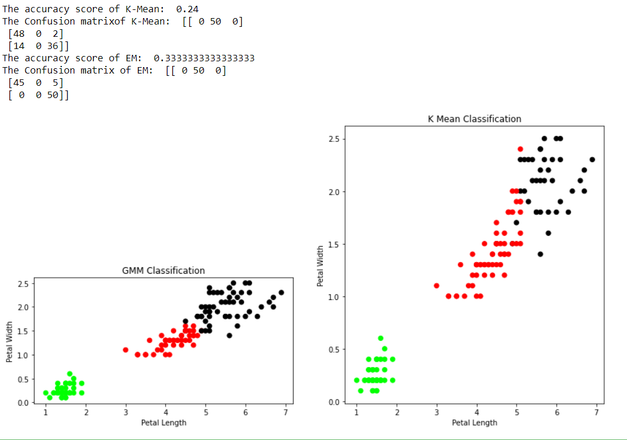

**9. Write a program to implement k-Nearest Neighbour algorithm to classify the iris data set. Print both correct and wrong predictions.**

from sklearn.model_selection import train_test_split

from sklearn.neighbors import KNeighborsClassifier

from sklearn.metrics import classification_report, confusion_matrix

from sklearn import datasets

iris=datasets.load_iris()

x = iris.data

y = iris.target

print ('sepal-length', 'sepal-width', 'petal-length', 'petal-width')

print(x)

print('class: 0-Iris-Setosa, 1- Iris-Versicolour, 2- Iris-Virginica')

print(y)

x_train, x_test, y_train, y_test = train_test_split(x,y,test_size=0.3)

#To Training the model and Nearest nighbors K=5

classifier = KNeighborsClassifier(n_neighbors=5)

classifier.fit(x_train, y_train)

#To make predictions on our test data

y_pred=classifier.predict(x_test)

print('Confusion Matrix')

print(confusion_matrix(y_test,y_pred))

print('Accuracy Metrics')

print(classification_report(y_test,y_pred))

**Output:**

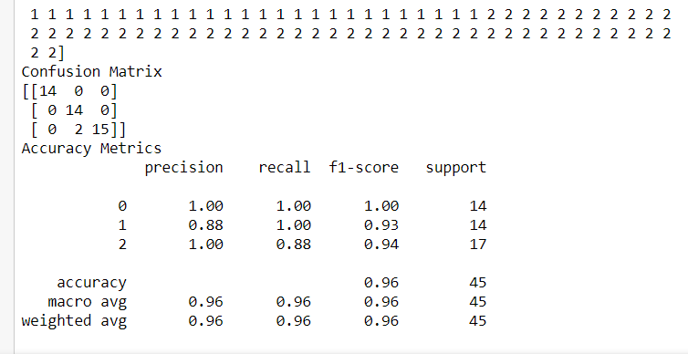

**10. Implement the non-parametric Locally Weighted Regression algorithm in order to fit data points. Select appropriate data set for your experiment and draw graphs.**

**a) Using built-in:**

import numpy as np

from bokeh.plotting import figure, show, output_notebook

from bokeh.layouts import gridplot

from bokeh.io import push_notebook

def local_regression(x0, X, Y, tau):# add bias term

x0 = np.r_[1, x0] # Add one to avoid the loss in information

X = np.c_[np.ones(len(X)), X]

# fit model: normal equations with kernel

xw = X.T * radial_kernel(x0, X, tau) # XTranspose * W

beta = np.linalg.pinv(xw @ X) @ xw @ Y #@ Matrix Multiplication or Dot Product

# predict value

return x0 @ beta # @ Matrix Multiplication or Dot Product for prediction

def radial_kernel(x0, X, tau):

return np.exp(np.sum((X - x0) ** 2, axis=1) / (-2 * tau * tau))

# Weight or Radial Kernal Bias Function

n = 1000

# generate dataset

X = np.linspace(-3, 3, num=n)

print("The Data Set ( 10 Samples) X :\n",X[1:10])

Y = np.log(np.abs(X ** 2 - 1) + .5)

print("The Fitting Curve Data Set (10 Samples) Y :\n",Y[1:10])

# jitter X

X += np.random.normal(scale=.1, size=n)

print("Normalised (10 Samples) X :\n",X[1:10])

domain = np.linspace(-3, 3, num=300)

print(" Xo Domain Space(10 Samples) :\n",domain[1:10])

def plot_lwr(tau):

# prediction through regression

prediction = [local_regression(x0, X, Y, tau) for x0 in domain]

plot = figure(plot_width=400, plot_height=400)

plot.title.text='tau=%g' % tau

plot.scatter(X, Y, alpha=.3)

plot.line(domain, prediction, line_width=2, color='red')

return plot

show(gridplot([

[plot_lwr(10.), plot_lwr(1.)],

[plot_lwr(0.1), plot_lwr(0.01)]]))

**Output:**

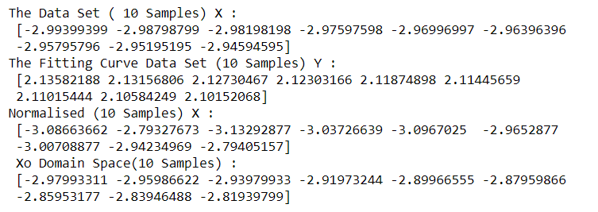

**b) Without using built-in:**

import matplotlib.pyplot as plt

import pandas as pd

import numpy as np

def kernel(point, xmat, k):

m,n = np.shape(xmat)

weights = np.mat(np.eye((m)))

for j in range(m):

diff = point - X[j]

weights[j,j] = np.exp(diff*diff.T/(-2.0*k**2))

return weights

def localWeight(point, xmat, ymat, k):

wei = kernel(point,xmat,k)

W = (X.T*(wei*X)).I*(X.T*(wei*ymat.T))

return W

def localWeightRegression(xmat, ymat, k):

m,n = np.shape(xmat)

ypred = np.zeros(m)

for i in range(m):

ypred[i] = xmat[i]*localWeight(xmat[i],xmat,ymat,k)

return ypred

data = pd.read_csv('10-dataset.csv')

bill = np.array(data.total_bill)

tip = np.array(data.tip)

#preparing and add 1 in bill

mbill = np.mat(bill)

mtip = np.mat(tip)

m= np.shape(mbill)[1]

one = np.mat(np.ones(m))

X = np.hstack((one.T,mbill.T))

ypred = localWeightRegression(X,mtip,0.5)

SortIndex = X[:,1].argsort(0)

xsort = X[SortIndex][:,0]

fig = plt.figure()

ax = fig.add_subplot(1,1,1)

ax.scatter(bill,tip, color='green')

ax.plot(xsort[:,1],ypred[SortIndex], color = 'red', linewidth=5)

plt.xlabel('Total bill')

plt.ylabel('Tip')

plt.show();

**Output:**

